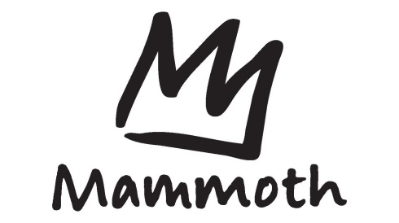

Stacey Cook Challenge
USSA/Far West U 14 Super G
February 28 – March 2, 2014
Itinerary

Sunday, March 2nd

- 7:30 am: Registration in Team HQ (Masters as well)
- 8:30 am: Broadway Express opens
- 8:45 – 9:15 am: Inspection
- 9:30 am: Ladies Race # 1
- 10:30 am: Men’s Race # 1
- 11:30 am: Masters Race # 1
- 11:45 – 12:15 pm: Slip
- 12:30 pm: Ladies Race #2
- 1:30 pm: Men’s Race # 2
- 2:30 pm: Masters Race # 2
- 3:00 pm: Awards

